

ASSIGNMENT NO. 1

DS-202 Data Structures.

Submitted by:
ARISHA ASHRAF

Submitted to:
SIR SABEEH

Roll no:
25011598-003

Degree program:
DATA SCIENCE SECTION A.

Course code:
DS-202

Submission date:
17-September-2026.

Topic: Implementing and executing arrays in “VISUAL STUDIO CODE”;

QUESTION NO.1:

A small library wants a simple program to manage the list of book IDs currently on a shelf. The shelf can hold a limited number of books at a time. The librarian needs a menu to manage this list from the console.

How I did it
- I made an int array of size 10 (arr) and a count variable that tells how many values are filled right now.
- Add just puts the new value at arr[count] and increases count by 1.
- Insert at index shifts all values after that index one place to the right first, then puts the new value in.
- Fill array keeps asking for values until the array becomes full, or the user types -9999 to stop early.
- Delete last just decreases count by 1 (easiest one).
- Delete by index shifts all values after it one place left to close the gap.
- Display, Search, Get and Replace all just loop through the array from 0 to count-1.
Also write advantages and disadvantages of array data structure

Advantages:
- You can directly access any element using its index, so Get and Replace are very fast.
- It is simple to code and does not need any extra memory for pointers like linked list.

Disadvantages:
- Size is fixed at the start, so once it is full you get overflow and cannot add more .
- Insert and Delete are slow because you have to shift elements every time.

Output / Screenshots
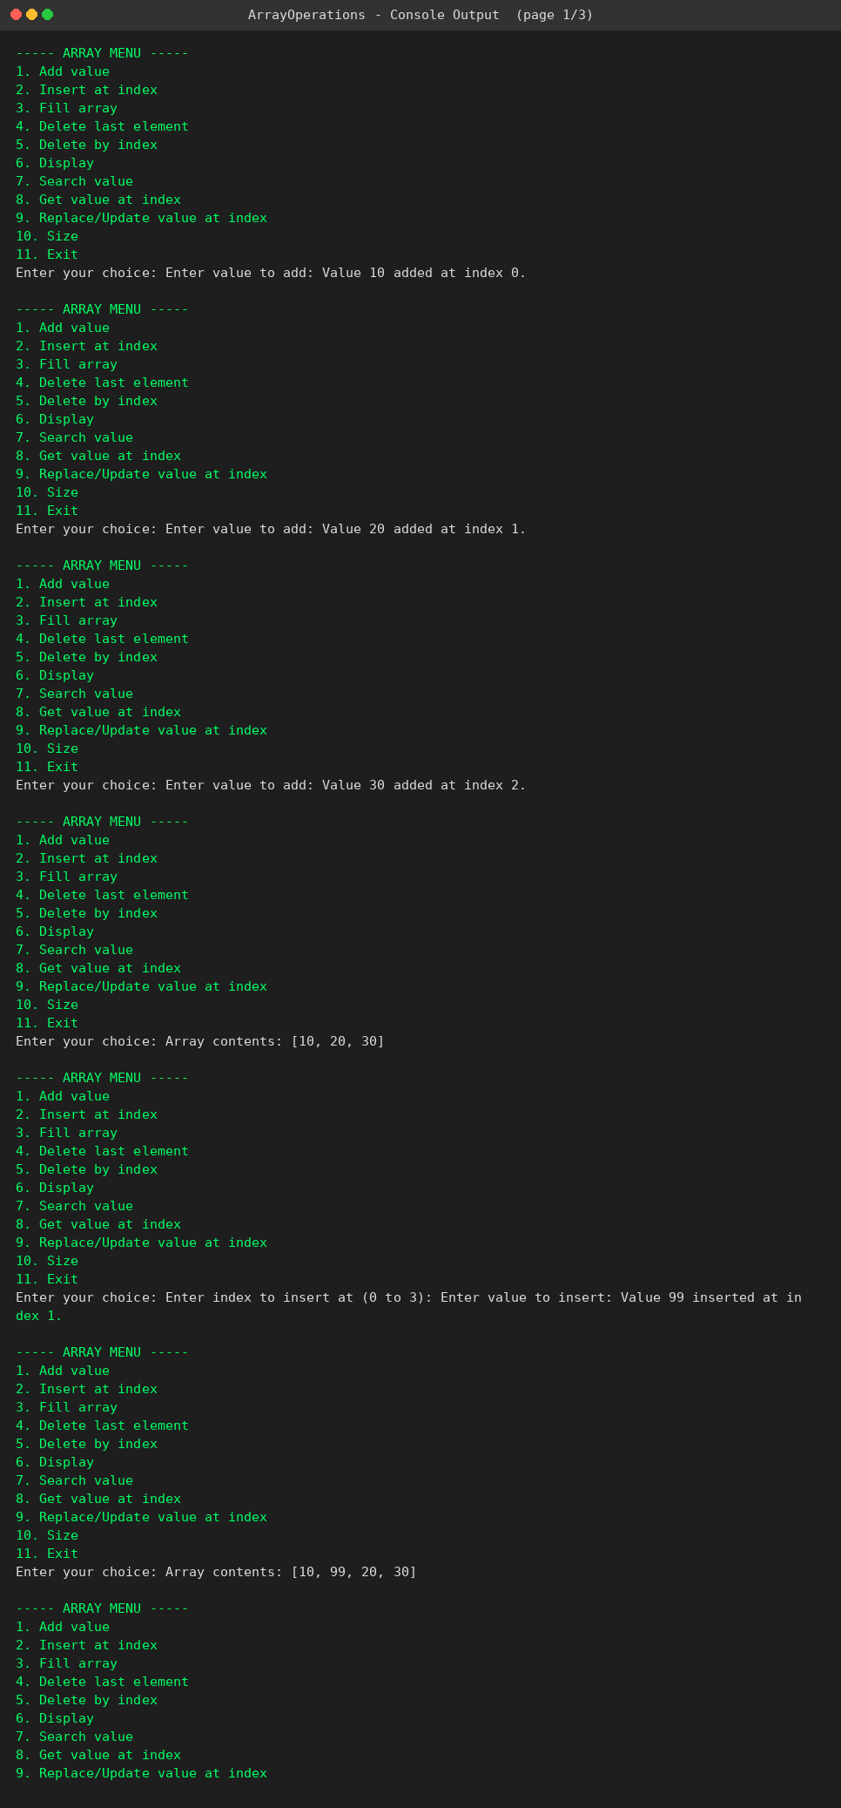
Add, Insert, Fill and Display
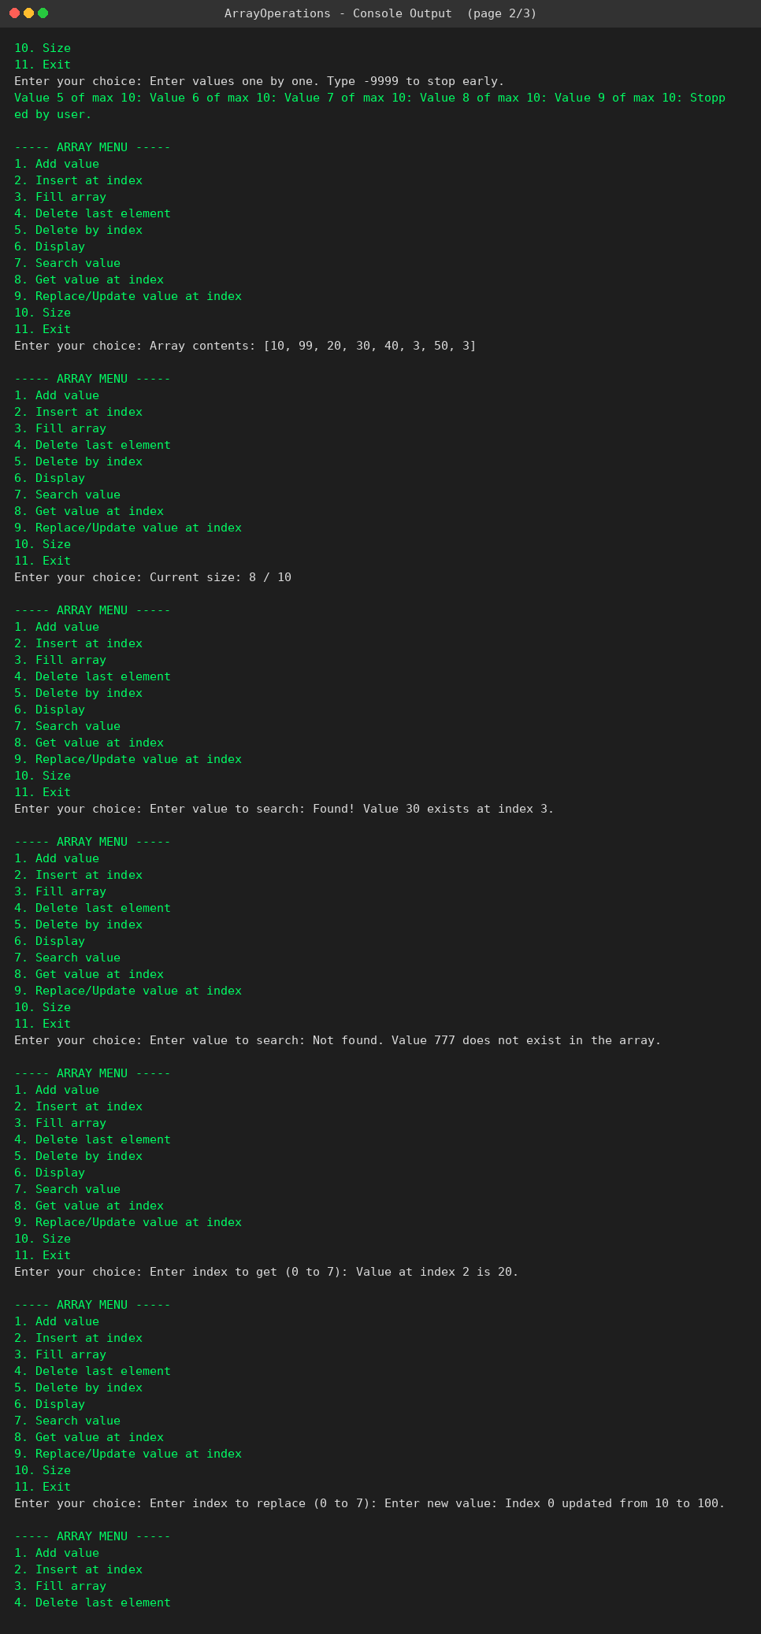
Search, Get and Replace/Update
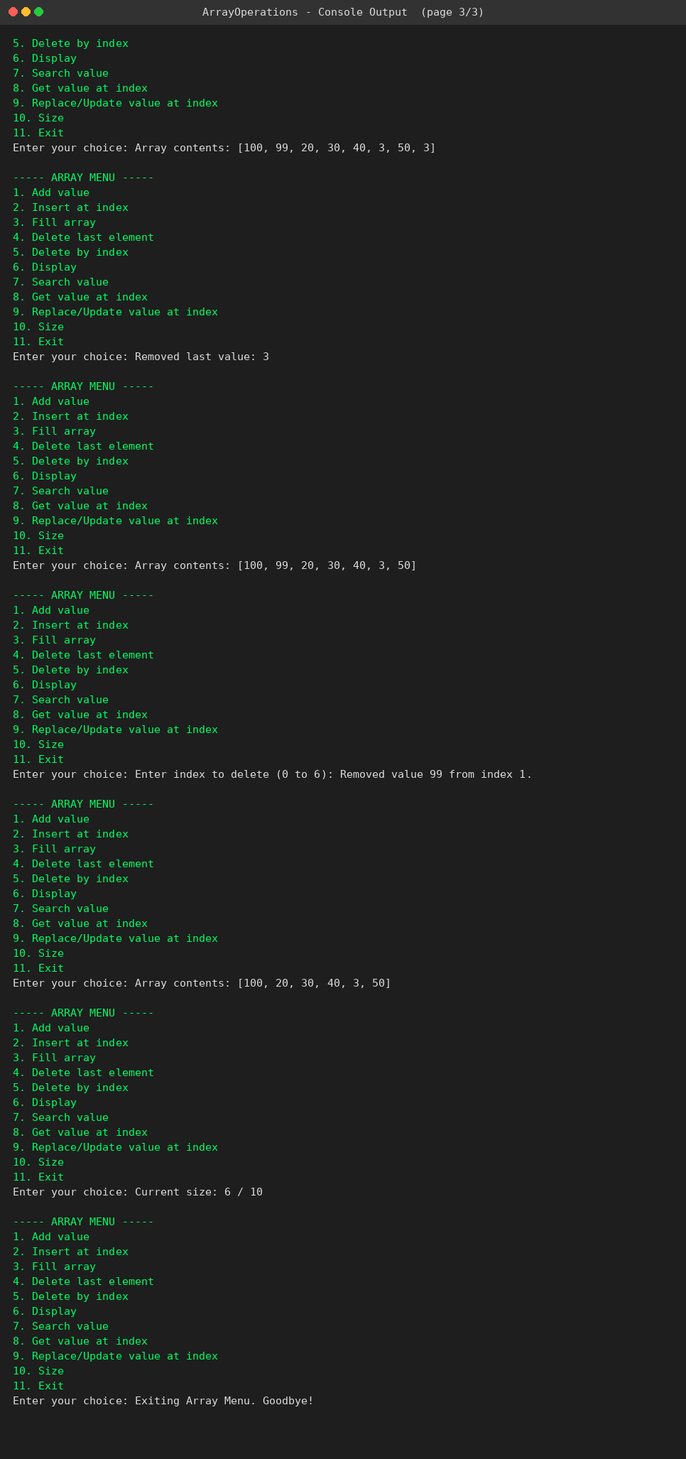
Delete Last, Delete by Index, Size and Exit
Question 2 - Stack Operation

Scenario: A pile of plates, where you can only add a plate on top (Push) and only remove the plate that is on top (Pop). I used one array and a top variable to keep track of the topmost plate.

How I did it

- Array size is 10 and top starts at -1, which means the stack is empty.
- Push increases top by 1 and puts the value there. If top reaches the last index, it shows Overflow.
- Pop takes the value from stack[top] and decreases top by 1. If top is -1, it shows Underflow.
- Display prints from top down to 0, so the last pushed value shows first (this is LIFO order).
- isEmpty and isFull just check the value of top.

Output / Screenshots
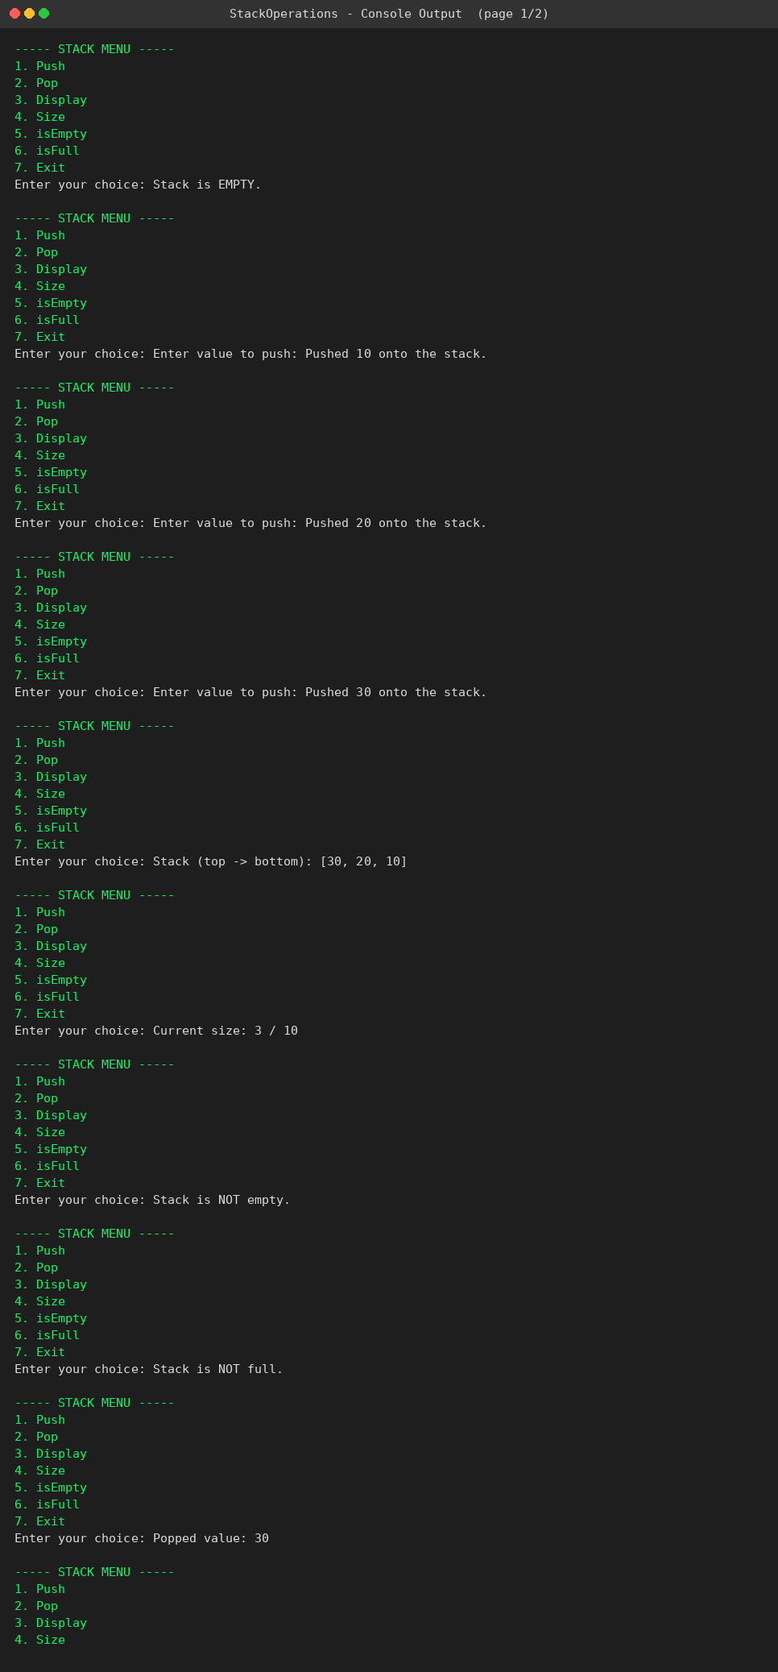
Push, Display, Size, isEmpty, isFull
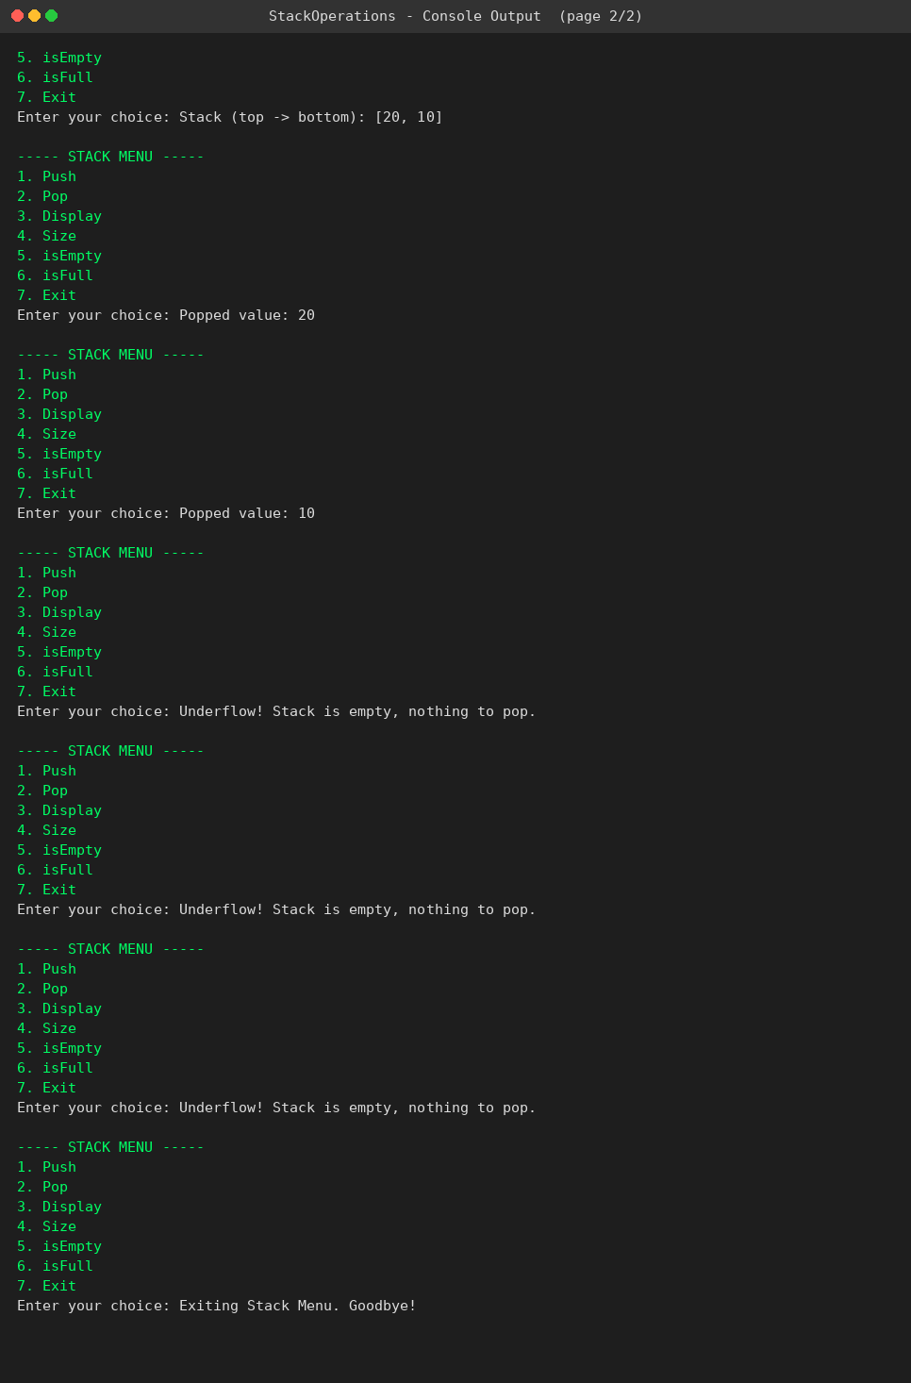
Pop in LIFO order + Underflow message
Question 3 - Queue Operations

Scenario: A bank counter gives token numbers to customers. New customers join the back of the line (Enqueue) and the counter serves the customer at the front first (Dequeue). I used an array with front and rear variables.

How I did it

- Array size is 10, front starts at 0, rear starts at -1, and count keeps track of how many tokens are waiting.
- Enqueue increases rear by 1 and puts the value there. If count == 10 it shows Overflow.
- Dequeue takes the value at queue[front] and increases front by 1. If count == 0 it shows Underflow.
- When the queue becomes completely empty I reset front and rear back to the start so the array can be reused.
- Display prints from front to rear, so it shows the order customers will be served in (FIFO order).

Output / Screenshots
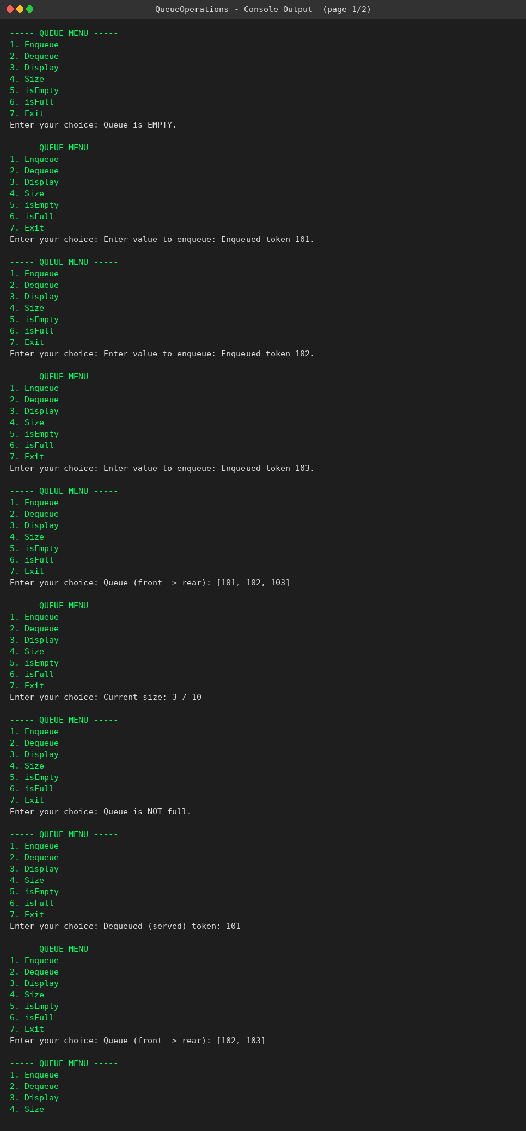
Enqueue, Display, Size, isFull

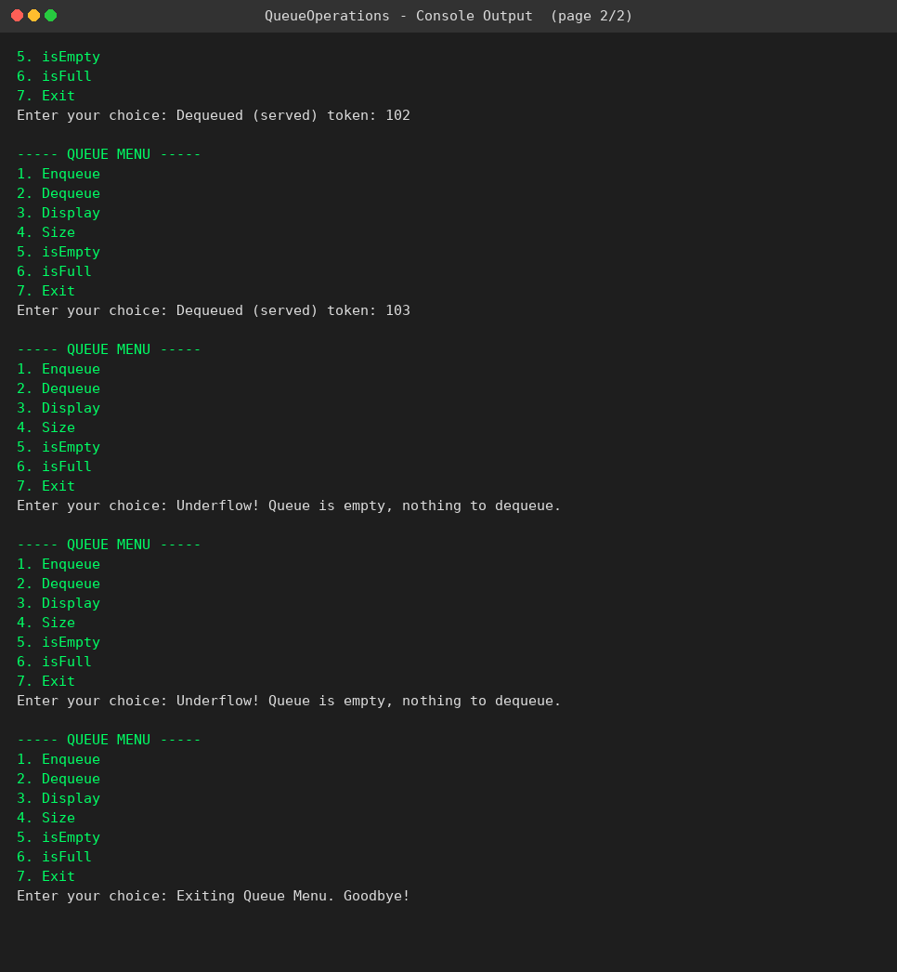
Dequeue in FIFO order + Underflow message

Question 4 - Real World Examples

5 real world examples for each data structure, with a short reason why it fits.

Array
- Class attendance register - fixed number of roll numbers, direct access by index.
- Pixels of a digital image - fixed grid, each pixel accessed by its position.
- Weekly temperature record - exactly 7 slots, one for each day.
- Top scores / leaderboard of a game - fixed number of rank positions.
- Marks of students in a class - number of students is already known.

Stack
- Undo option in MS Word / any editor - last typed action is undone first (LIFO).
- Back button in a browser - last visited page opens first when you go back.
- Function calls in recursion - the most recent call finishes first.
- Checking brackets in code (compiler) - last opened bracket must close first.
- A pile of plates in a canteen - literally same as the stack example.

Queue
- Token system at a bank counter - first token gets served first (FIFO), same as my program.
- Print jobs sent to one printer - printed in the order they were sent.
- CPU scheduling of processes (First Come First Serve).
- People on hold in a call centre - first caller connected first.
- Messages/notifications - shown in the order they arrive.

Question 5 - Advantages and Disadvantages

- Advantage: Very fast to get or update a value using its index (O(1)).
- Advantage: Easy to write and understand, no extra memory used for pointers.
- Disadvantage: Fixed size, so it can overflow, and insert/delete is slow because of shifting.

Stack
- Advantage: Push and Pop are both very fast since only the top changes.
- Advantage: Very easy to implement, matches LIFO situations perfectly.
- Disadvantage: Fixed size can overflow, and you cannot access middle elements without popping everything above them.

Queue
- Advantage: Enqueue and Dequeue are both fast , matches FIFO situations like the bank token system.
- Advantage: Simple to implement with just front and rear variables.
- Disadvantage: Once dequeued, that space in the array is wasted unless the queue empties completely (not circular in my version), and it also has a fixed max size.

